1st query:

  
result:  


2nd, query:

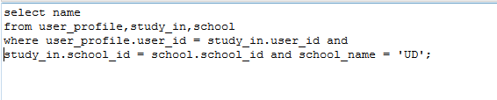

Result:

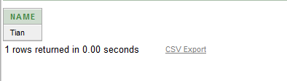

3rd query:





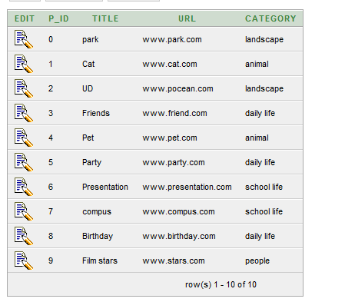

4,

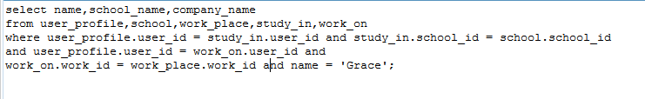

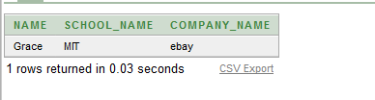

5,





6,



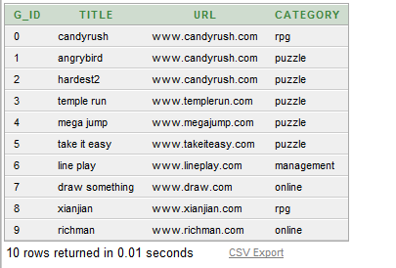

7,



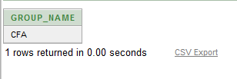

8,

When someone’s birthday is inserted or updated to less than '01-JAN-1900'

It will change the input value and change to the '01-JAN-1900' as the default birthday.

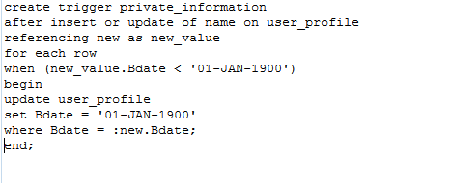

9

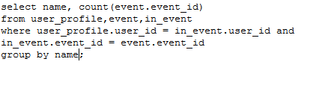

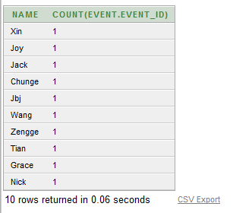

10,



